Fabrication and Performance of ESP-T for Hydraulic Fracturing in Unconventional Oil and Gas Reservoirs

Abstract：Against the backdrop of the surging global demand for the exploitation of unconventional oil and gas resources, the accurate monitoring of oil production contribution from individual fracturing segments has become a pivotal prerequisite for optimizing reservoir development strategies and enhancing ultimate oil recovery efficiency. In this study, an oleophilic Fe₃O₄-doped epoxy resin tracer proppant (ESP-T) was rationally designed and fabricated, with epoxy resin serving as the matrix and stearic acid-modified metal-doped nano-Fe₃O₄ (nano-Fe₃O₄@SA) as the lipophilic tracer. Emulsion polymerization was employed to achieve the stable immobilization of the tracer within the epoxy carrier matrix, thus constructing an integrated proppant system with dual functions of fracture propping and production monitoring. Systematic characterizations were conducted to investigate the microstructural features, mechanical properties, thermal stability, surface wettability, and oil-water permeability of the as-prepared ESP-T. Moreover, the temperature-dependent release behavior and kinetic mechanism of the tracer were elucidated, and the feasibility and accuracy of ESP-T for oil production monitoring were validated through a series of core displacement experiments under single-phase and two-phase flow conditions.

The results demonstrate that nano-Fe₃O₄@SA is uniformly dispersed in the epoxy matrix in the form of nanoclusters without obvious agglomeration, and the ESP-T exhibits a sphericity and roundness both in excess of 0.9, complying with the industrial forming criteria for fracturing proppants. ESP-T possesses excellent physical, mechanical and thermal stability: it has a bulk density of 0.646 g·cm⁻³, endowing it with favorable suspendability in aqueous fracturing fluids; an apparent density of 1.072 g·cm⁻³, indicative of a compact internal structure; a low breakage rate under a confining pressure of 50 MPa; and an acid solubility of 3.3%, which meets the industrial standard of ≤5% and thus renders it applicable to acidic oil and gas reservoirs. The initial thermal weight loss temperature of ESP-T reaches 357.27 ℃, which is far higher than the typical downhole temperature range (80–200 ℃) of unconventional reservoirs, eliminating the risk of resin matrix degradation during long-term downhole service. The water contact angle (WCA) of ESP-T increases from 72.3° (weak hydrophilicity of pure epoxy microspheres) to 104.6° (hydrophobicity), endowing the proppant with a distinctive transport characteristic of "enhanced water resistance and reduced oil resistance": the water filtration time of ESP-T is extended to 28 min 41 s (significantly longer than that of pure epoxy microspheres), while the oil filtration time is shortened to 5 min 11 s (a 66.1% reduction compared with pure epoxy microspheres), which can effectively facilitate oil phase flow and inhibit water phase breakthrough in reservoirs.

In terms of tracer performance, the release of Fe element from ESP-T at 30–120 ℃ conforms to the Korsmeyer-Peppas (K-P) kinetic model. Fitting results reveal that the diffusion exponent n at all tested temperatures falls within the range of 0.45–0.85, indicating that the tracer release mechanism is governed by the synergy of Fickian diffusion and Case-II relaxation. The correlation coefficient R² of all fittings is greater than 0.90, and the cumulative release concentration of the tracer at 120 ℃ for 14 days exceeds 2.0 mg·L⁻¹, which meets the detection sensitivity requirement of Inductively Coupled Plasma Mass Spectrometry (ICP-MS) and enables long-term and stable downhole oil production monitoring. Under the shut-in single-phase flow condition, the R² of the fitting via the dynamic release interpretation model is above 0.9, and the relative error between the fitted flow rate (0.46 mL·min⁻¹) and the actual pump-set flow rate (0.5 mL·min⁻¹) is merely 8%, verifying the high accuracy of ESP-T for oil production monitoring in single-phase flow scenarios. Under the steady-state oil-water two-phase flow condition, the tracer concentration exhibits a monotonic decrease with the increase of total two-phase flow rate and is independent of the oil-water ratio. By introducing the concept of tracer flux, the variation of oil flow rate in a single fracturing segment can be effectively characterized, which provides a reliable technical basis for the dynamic monitoring of oil flow during the steady-state production stage of reservoirs.

In conclusion, the developed ESP-T integrates the dual functionalities of fracture propping and tracer monitoring, and is adaptable to diverse harsh downhole scenarios including acidic oil and gas reservoirs, deep wells and high-pressure formations. It can provide robust technical support for the optimization of oilfield fracturing parameters and the improvement of crude oil recovery, thus possessing considerable industrial application potential and promising prospects for field application in unconventional oil and gas development.

Key words: Unconventional oil and gas reservoirs; Hydraulic fracturing; Tracer proppant; Epoxy resin; Fe₃O₄ nanoparticles; Oil production monitoring; Release kinetics

1 Introduction
Amid the sustained surge of global energy demand, unconventional oil and gas resources have emerged as the central focus of contemporary petroleum development owing to their immense reserve potential [1-5] . To date, unconventional oil and gas resources account for more than 53% of the world’s total hydrocarbon reserves [6, 7], and their efficient development constitutes a critical pillar of global energy security. As the core technology for stimulating unconventional oil and gas reservoirs, hydraulic fracturing establishes artificial fractures to optimize hydrocarbon seepage pathways, thereby substantially boosting the productivity of low-permeability and tight formations [8]. Nevertheless, the oil production contribution of each fractured interval varies markedly post-fracturing, and interval productivity decays at disparate rates as field development proceeds [9]. Accurate monitoring of the production contribution rate of individual fractured intervals not only supplies key data for reservoir productivity assessment but also guides the optimization of subsequent development strategies, ultimately elevating the overall hydrocarbon recovery factor.

Tracer technology has become the mainstream approach for monitoring the production contribution of fractured intervals, distinguished by its low cost, operational simplicity, and independence from sophisticated downhole equipment [10]. In contrast to conventional production monitoring methodologies (e.g., well-test analysis, downhole distributed fiber-optic sensing, and microseismic monitoring), tracer technology intuitively reflects fluid flow dynamics via concentration variations in produced fluids, drastically cutting equipment procurement and maintenance costs. Initially applied in hydrological research, tracer technology was later extended to characterize inter-well fluid flow in water-flooded reservoirs and evaluate reservoir connectivity in oilfields[11-13]. With the maturation of staged fracturing, it has been widely adopted to quantify the production contribution of each fractured interval [14]. Relative to conventional water-soluble tracers, oil-soluble tracers yield more reliable production contribution data by analyzing dynamic concentration profiles in crude oil.

Despite the inherent drawbacks of oil-soluble tracers—including poor compatibility with fracturing fluid injection and inability to support long-term monitoring—tracer proppants, as composite materials integrating fracture propping and tracer monitoring functions, have effectively addressed these limitations. By immobilizing tracers within proppant carriers, tracer proppants enable long-term dynamic monitoring of fractured intervals upon co-injection with fracturing fluids, eliminating the cumbersome procedure of separate tracer injection. For instance, Zhao et al. (2020) [15] coated rhodamine 6G onto polyvinyl alcohol-modified ceramic particles via solvent evaporation to retard its release in aqueous media. Zhou et al. (2022) [16] encapsulated carbon quantum dots (CQDs) in polyvinyl alcohol-coated ceramic particles to achieve controllable tracer release. Malyavko et al. (2023) [17] employed monodisperse microspheres doped with fluorescent semiconductor nanocrystals as tracers, and coated them with gas-philic, oleophilic, and hydrophilic polymers to precisely acquire phase distribution data for each fractured interval. Li et al. (2023) [18] utilized rare-earth elements as tracers and encapsulated them with ammonium polymethacrylate to elucidate the slow-release mechanism. Furthermore, Gong et al. (2024) [19] fabricated slow-release tracer proppants by embedding tracers into polystyrene (PS) microspheres via suspension polymerization and investigated their controlled-release mechanism.

However, conventional coated tracer proppants suffer from high density, which impedes transport in fracturing fluids, and loses monitoring functionality once the polymer coating is fully dissolved; pure PS microspheres exhibit inferior mechanical strength and thermal stability [20-23] . Accordingly, epoxy resin—a high-performance polymer with exceptional mechanical strength, thermal stability, and chemical resistance—has been integrated into proppant design, typically as a coating or composite matrix to enhance overall proppant performance. Coating proppants with epoxy resin significantly reduces the crush rate, improves compressive strength and acid resistance, while retaining the low-density advantage [24, 25] . This modification enhances high-temperature stability, mitigates fine-particle generation and equipment abrasion, and sustains long-term fracture conductivity. Despite notable advances in coating technology, it remains constrained by challenges including uneven coating, interfacial debonding risks, and complex preparation procedures. As a further optimized alternative, direct synthesis of epoxy resin microspheres as proppants enables low-density tailoring via synthetic regulation and facilitates nanoparticle modification and tracer encapsulation. Li Haitao et al. (2021) [26] experimentally explored the release mechanism of water-soluble tracers from epoxy resin in aqueous environments. Wei et al. (2024) encapsulated water-soluble tracers (e.g., fluorobenzoic acid, sodium bromide) in an epoxy resin matrix to locate water-producing intervals in oil wells. Nevertheless, research on epoxy resin as an oleophilic release matrix remains inadequate.

In response to this research gap, this study designed and synthesized an oleophilic metal-doped Fe₃O₄/epoxy resin tracer proppant (ESP-T). Using epoxy resin as the matrix and stearic acid-modified metal-doped nano-Fe₃O₄@SA as the oleophilic tracer, stable tracer-carrier integration was achieved via emulsion polymerization. We systematically characterized the microstructure, mechanical properties, thermal stability, wettability, and oil–water permeability of the novel proppant, investigated tracer release behavior and kinetic mechanisms at varying temperatures, and validated its oil production monitoring performance through laboratory experiments. This work aims to develop a multifunctional proppant featuring low-density suspendability, high compressive resistance, and reliable tracing performance, providing an innovative technical solution for hydraulic fracturing stimulation and productivity monitoring of unconventional oil and gas reservoirs.

2 Experiments

2.1 Materials
All chemical reagents used in the experiments were of analytical grade or industrial grade and used without further purification. Analytical Grade (AR) reagents, including ethanol (purity ≥99.7%), ferric chloride (FeCl₃, purity ≥99.0%), ferrous chloride tetrahydrate (FeCl₂·4H₂O, purity ≥99.0%), manganese chloride hexahydrate (MnCl₂·6H₂O, purity ≥99.0%), stearic acid (purity ≥99.5%) and silicon dioxide (SiO₂, purity ≥99.99%), were purchased from Chengdu Kelong Chemical Co., Ltd. Industrial grade reagents included guar gum (purity 90%–95%), E51 epoxy resin (epoxy value meeting industrial standards, purity ≥99%), T31 curing agent (effective component content 95%) and hollow glass microspheres (main component purity ≥99%). The detailed specifications and sources of all materials are summarized in Table 1.

Table 1 Specifications and sources of experimental materials
Reagents | Purity | Manufacturers
Ethanol | Analytical pure | Chengdu Kelong Chemical Co., Ltd
Ferric chloride | Analytical pure | Chengdu Kelong Chemical Co., Ltd
Ferrous chloride tetrahydrate | Analytical pure | Chengdu Kelong Chemical Co., Ltd
Manganese chloride hexahydrate | Analytical pure | Chengdu Kelong Chemical Co., Ltd
Stearic acid | Analytical pure | Chengdu Kelong Chemical Co., Ltd
silica | Analytical pure | Chengdu Kelong Chemical Co., Ltd
Guanidine gum
E51 type epoxy resin
T31 type curing agent
Insulating glass microspheres

2.2 Fabrication of stearic acid-modified nano-Fe₃O₄ (nano-Fe₃O₄@SA)
A clean three-necked flask was mounted in a thermostatic water bath and connected to nitrogen purge and mechanical stirring apparatuses. The flask was charged with 100 mL deionized water and heated to 80 ℃. Upon reaching the target temperature, 2.703 g (0.01 mol) FeCl₃ was added, and the system was purged with nitrogen for 15 min, followed by the introduction of 1.15 g (0.058 mol) FeCl₂·4H₂O and 2×10⁻⁵ mol MnCl₂·4H₂O. After stirring for 10 min, 5.5 mL ammonia solution was rapidly added, and the reaction proceeded at pH 10 for 2 h. Upon completion, the resulting black suspension was transferred to an Erlenmeyer flask and magnetically separated, with the supernatant discarded. The precipitate was washed with anhydrous ethanol under sonication repeatedly until neutral pH, then collected. Finally, the precipitate was blended with an ethanolic stearic acid solution and subjected to sonication for oleophilic modification. After washing, the product was diluted to 100 mL and stored for subsequent use [28].
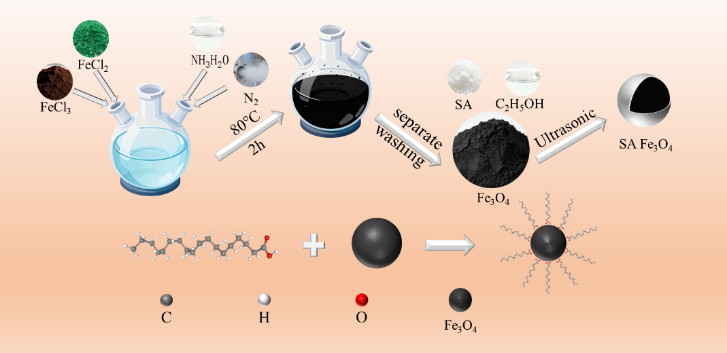
Fig.2-1 Schematic illustration for the preparation of stearic acid-modified metal-doped Fe₃O₄ nanoparticles

2.3 Preparation of pure epoxy resin microspheres
A clean beaker was placed on a magnetic stirrer, and 150 mL deionized water together with 0.3 g of 20 nm SiO₂ was added. The mixture was stirred at 380 RPM to prepare an aqueous dispersion, which was reserved for subsequent use. Meanwhile, 0.9 g guar gum and 0.5 g of 45 μm SiO₂ were weighed and set aside. In a separate vessel, 20 mL E51 epoxy resin, 6 g ethanol, 1 g hollow glass microspheres, and 7 g T31 curing agent were homogenized by manual stirring for 3 min to form a uniform pre-mixture. The epoxy pre-mixture was then transferred into the SiO₂ aqueous dispersion and agitated for 1 min to complete emulsification. Subsequently, 45 μm SiO₂ was introduced with continuous stirring, followed by the addition of guar gum to viscosify and stabilize the system. Stirring was terminated once microspheres were formed. The resulting product was cured in a 50 ℃ water bath for 1 h, rinsed thoroughly with deionized water, and dried in an 80 ℃ oven for 10 h to obtain epoxy resin microspheres. Stirring at 380 RPM effectively prevented particle agglomeration; hollow glass microspheres provided internal structural support; and guar gum suppressed the sedimentation and deformation of epoxy droplets, thereby guaranteeing the structural integrity of the final microspheres.
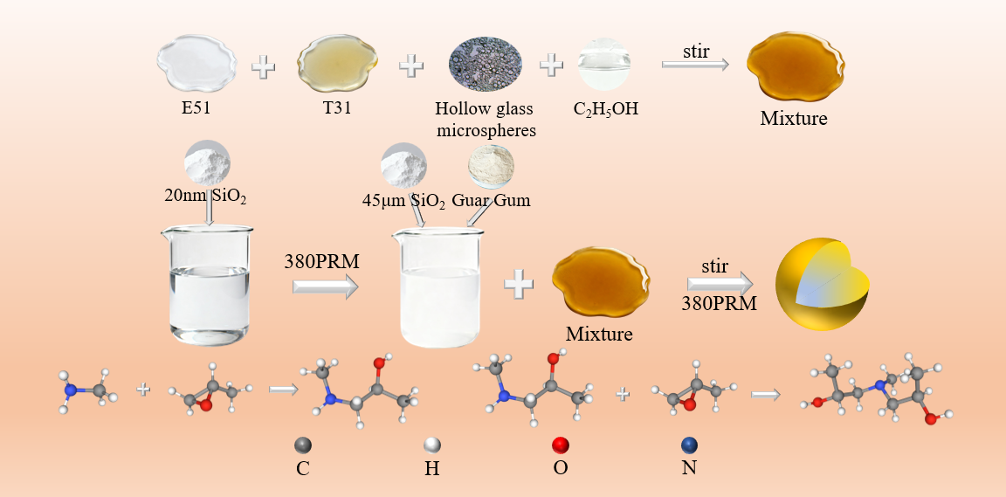
Fig.2-2 Schematic illustration for the preparation of epoxy resin microspheres

2.4 Preparation of ESP-T
The overall synthetic procedure for ESP-T was identical to that for epoxy resin microspheres detailed in Section 2.3, including preparation of the nano-SiO₂ aqueous dispersion, premixing of the epoxy resin system, sequential feeding for emulsification, thickening and stabilization with guar gum, as well as thermal curing and drying. Nevertheless, two critical adjustments were made to the epoxy mixture composition and supporting additives: first, 6 g of Fe₃O₄–ethanol mixture was used to fully replace pure ethanol to incorporate magnetic components into the microspheres; second, the dosage of guar gum for system stabilization was increased from 0.9 g to 1.1 g to accommodate the aforementioned modification.
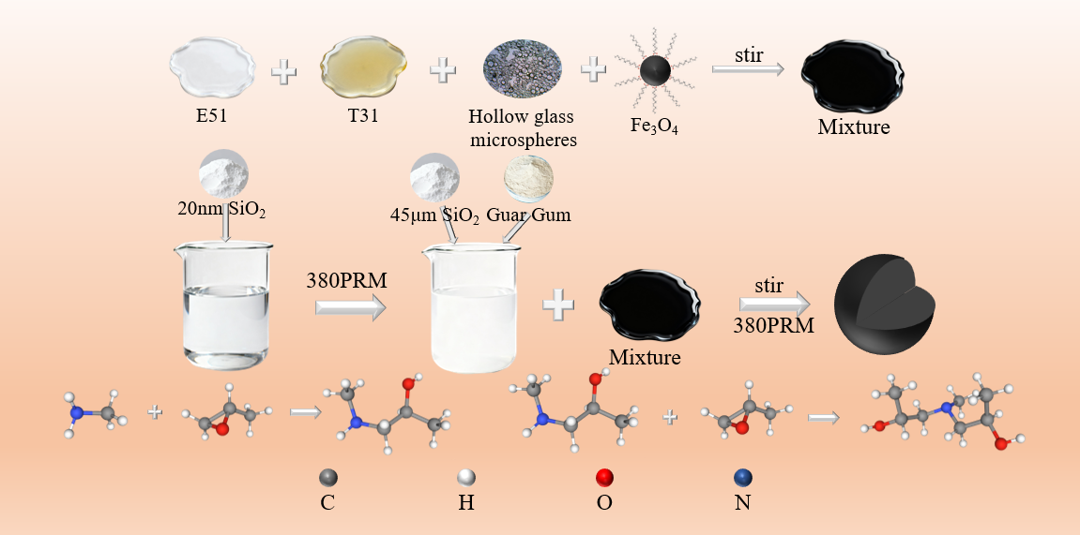
Fig.2-3 Schematic illustration for the preparation of Fe₃O₄-encapsulated epoxy resin proppants

2.5 Characterization Methods
The microstructure, elemental composition and distribution of neat epoxy resin microspheres and ESP-T were analyzed by scanning electron microscopy (SEM, ZEISS-Sigma 500). Samples were sputter-coated with a thin conductive metal layer under vacuum, mounted onto conductive adhesive tape, and observed at magnifications ranging from low power up to 50,000×. Characteristic X-rays were excited by a field-emission electron gun, and two-dimensional elemental mapping was performed over a selected region to visualize the distribution of Fe element in the proppants.

Surface morphology and particle dispersion of neat epoxy resin microspheres and ESP-T were examined using an optical microscope (Leica DM2700P). Thermogravimetric analysis (TGA, TA Instruments Q500, USA) was conducted to evaluate the thermal stability of the two proppants. Tests were performed in air atmosphere at a heating rate of 10 ℃/min over a temperature range of 50–800 ℃.

Water contact angle (WCA) measurements were carried out using a video optical contact angle analyzer (OCA20, Germany). Pressed proppant flakes were placed on the test stage, and a 5 μL droplet of deionized water was deposited onto the sample surface. Images were captured after the droplet stabilized, and five replicate measurements were performed for each sample.

The physical and mechanical properties as well as field applicability of the proppants were comprehensively evaluated using roundness, sphericity, bulk density, apparent density, acid solubility and crush rate. The oil–water conductivity of the proppants was indirectly assessed via filtration time. The bottom of a funnel was blocked with a 200-mesh screen to prevent proppant leakage while allowing water or oil to pass through. A total of 2.0 g of proppant was loaded into the funnel, followed by the addition of 20 mL deionized water or dodecane, and the time required for complete permeation was recorded.

2.6 Experimental Design of Tracer Release Behavior at Different Temperatures
Glass vials containing 100 mL dodecane were placed in thermostatic oil baths set at 30 ℃, 60 ℃, 90 ℃ and 120 ℃, respectively, followed by the addition of 5 g of 40–70 mesh ESP-T. The vials were then hermetically sealed to prevent dodecane volatilization. Sampling was conducted at 12 h intervals, and the concentration of tracer-doped metal ions in the dodecane medium was quantified via inductively coupled plasma mass spectrometry (ICP-MS, PerkinElmer NexION 300X), from which the time-dependent tracer release curves were plotted.
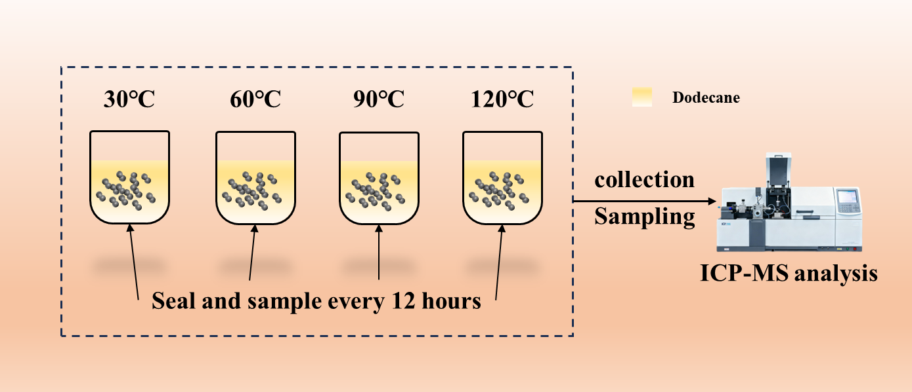
Fig. 2-5 Schematic diagram of the tracer release apparatus at different temperatures

2.7 Experimental Design of Oil Production Monitoring with ESP-T
For the single-phase oil production monitoring experiment of ESP-T, dodecane was employed to simulate crude oil, with the focus on the steady oil production regime of a single fractured interval. A dynamic displacement apparatus was utilized to mimic the dynamic oil production behavior of horizontal wells, as illustrated in Figure 2-6. First, the pore spaces of a steel core were packed with ESP-T, and both ends of the steel core were sealed with 200-mesh metal screens to prevent proppant migration with the flowing fluid. Subsequently, the proppant-packed steel core was placed into a core holder, and a confining pressure of 5 MPa was applied to simulate reservoir overburden pressure. The inlet of the core holder was connected to a constant-flow pump, and the outlet was linked to a tubing string to replicate the hydraulic fracturing production environment of horizontal wells. Dodecane was then pumped into the system at a flow rate of 5 mL/min until the tubing string was completely saturated with dodecane, after which the displacement was halted and the outlet valve was closed. The system was left undisturbed for 96 h to facilitate sufficient tracer release from ESP-T. Thereafter, dodecane was injected at a flow rate of 0.1 mL/min to displace the fluid within the core, simulating the oil production of the target fractured interval. Sampling was conducted at 10-min intervals, with 1 mL of effluent collected per sample for a total of 20 sets. The concentrations of the labeled elements in the collected samples were quantified via inductively coupled plasma mass spectrometry (ICP-MS).

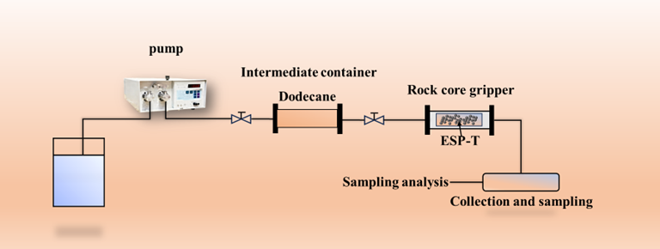
Fig. 2-6 Schematic diagram of the single-phase oil flow experimental apparatus

For the oil–water two-phase flow produced fluid monitoring experiment, the tracer was maintained in a stable release regime throughout the steady-flow period (i.e., no well shut-in was implemented during sampling and monitoring, with continuous oil well production sustained). The total two-phase flow rate and oil–water ratio of the displacement fluid were modulated by adjusting the injection rates of dodecane and water, thereby simulating the actual downhole oil–water two-phase flow conditions. The two-phase displacement apparatus is illustrated in Figure 2-7. Three oil–water volume ratios (4:1, 1:1, 1:4) and four total two-phase flow rates (0.1, 0.2, 0.3, 0.4 mL/min) were employed to evaluate the steady-state monitoring performance of the proppant. First, the proppant-packed steel core was placed into a core holder, and a confining pressure of 5 MPa was applied to the system. Subsequently, dodecane and water were co-injected into the core to conduct the flow simulation. Sampling was carried out at 5-min intervals during the multiphase displacement experiment, with 2 mL of effluent collected per sample for a total of 20 sets. The volume ratio of the dodecane phase to the aqueous phase in the collected samples was recorded, and the concentrations of the labeled metal elements were ultimately quantified via inductively coupled plasma mass spectrometry (ICP-MS).

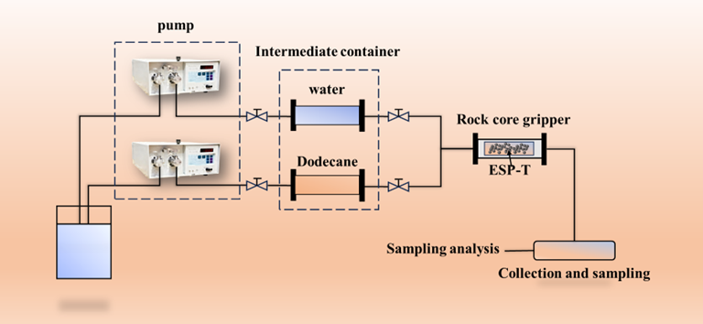
Fig. 2-7 Schematic diagram of the oil–water two-phase flow experimental apparatus

3 Results and Discussion

3.1 SEM Characterization
Figure 3-1 presents the SEM micrographs of pure epoxy resin microspheres and ESP-T proppants. At low magnification (a, d), both microsphere samples exhibit excellent sphericity and high monodispersity, with uniform particle sizes and no inter-particle agglomeration. This attests to the excellent controllability of the suspension polymerization preparation process and the uniformity of the curing reaction throughout synthesis. Notably, well-formed spherical epoxy resin microspheres can be stably fabricated with or without the incorporation of nano-Fe₃O₄@SA nanofillers. A direct comparison of (a) and (d) reveals that pure epoxy resin microspheres (a) feature a relatively smooth surface with minor particulate debris at low magnification, whereas ESP-T microspheres (d) exhibit a uniformly rough surface topography. This observation serves as preliminary evidence for the successful introduction of nano-Fe₃O₄@SA nanofillers and their significant modulation of the microsphere surface morphology.

At medium magnification (b), pure epoxy resin microspheres display subtle surface wrinkles and depressions—a typical morphological feature of thermosetting resins arising primarily from volume shrinkage during the epoxy curing process. In contrast, ESP-T microspheres (e) are uniformly covered with numerous micro/submicron-scale convex protrusions at the same magnification. These protrusions exist as well-dispersed island-like structures rather than large agglomerates, confirming that nano-Fe₃O₄@SA is dispersed within the epoxy matrix as nanoclusters instead of individual nanoparticles. This unique morphology demonstrates that stearic acid surface modification effectively suppresses severe, uncontrolled macroscopic phase separation, enabling the favorable dispersion state of nanoscale agglomeration and microscale uniformity for the nanofillers.

At high magnification, the fine surface microstructure of the microspheres is clearly resolved. Pure epoxy resin microspheres (c) exhibit a relatively dense yet undulating lava-like surface structure, a typical morphological feature of cross-linked epoxy polymer networks. In contrast, ESP-T microspheres (f) display a debris-like surface structure, corresponding to stearic acid-wrapped nano-Fe₃O₄@SA nanoclusters. The irregular morphology of these nanoclusters stems from the agglomeration of individual nanoparticles and the self-assembly and structural reconstruction of the stearic acid modifier during the epoxy curing process. Notably, no distinct interfacial cracks are observed between these debris-like nanoclusters and the underlying epoxy matrix, with the nanofillers exhibiting an embedded bonding state rather than a simple surface-attached one. This observation verifies that the long alkyl chains of stearic acid form strong physical entanglement and hydrophobic interactions with epoxy resin molecular chains, yielding robust interfacial adhesion between the nanofillers and the epoxy matrix—direct evidence for the successful surface modification of nano-Fe₃O₄@SA.

A plausible formation mechanism for this surface morphology is as follows: the hydrophobically modified nano-Fe₃O₄@SA nanoclusters are uniformly dispersed within epoxy resin droplets post-emulsification; as the epoxy cross-linking reaction proceeds, a rigid polymer network is formed, effectively "freezing" the nanoclusters in their original positions. During the subsequent curing shrinkage process, a portion of these nanoclusters is extruded toward the microsphere surface, resulting in the surface-enriched rough nanostructures observed in (e) and (f).

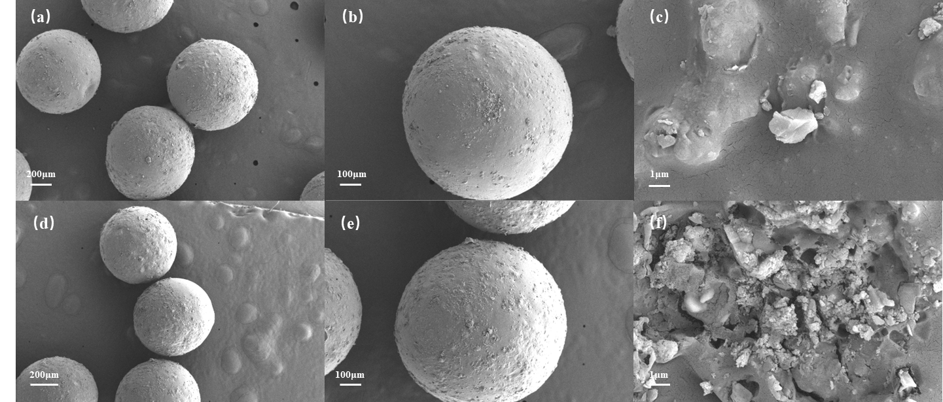
Figure 3-1 SEM images of epoxy microspheres and Fe3O4@epoxy proppants. The epoxy microspheres are on the top of the figure, and the Fe3O4@epoxy proppants are at the bottom. (a) and (d) are SEM images of multiple whole microspheres, (b) and (e) are SEM images of a single whole microsphere, and (e) and (f) are SEM images of local parts.

SEM elemental mapping (Figure 3-2) visually illustrates the distribution of the primary Fe and Si elements within the proppant. The Fe elemental signal, represented in the yellow mapping image, is dispersed throughout the entire proppant particle, demonstrating the presence of Fe-containing components in the particle’s main matrix and serving as direct evidence for the successful encapsulation of nano-Fe₃O₄@SA within the epoxy resin matrix of the microspheres. Minor inhomogeneities in the Fe signal intensity across the particle indicate a slight non-uniformity in Fe distribution, a phenomenon that may be attributed to the presence of distinct phase domains within the composite. Collectively, these elemental mapping results validate the successful synthesis of the ESP-T proppant.
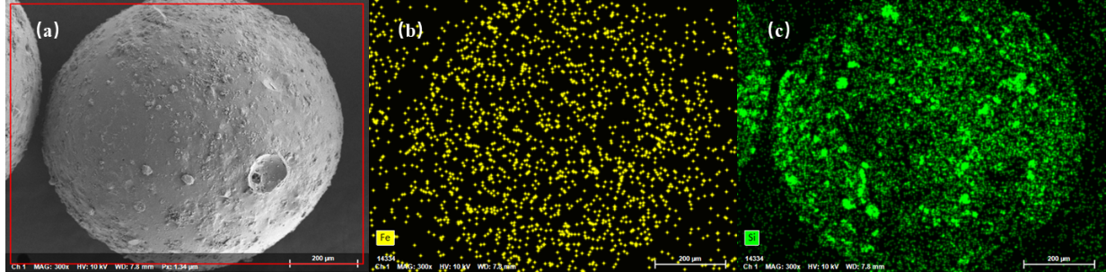
Figure 3-2 Mapping images of Fe3O4@epoxy resin proppant. (a) SEM image of Fe3O4@epoxy resin proppant, (b) Distribution of Fe element, (c) Distribution of Si element

3.2 Morphological Characterization via Optical Microscopy
Figure 3-3 displays the optical micrographs of neat epoxy resin microspheres and ESP-T. At low magnification (a, d), neat epoxy microspheres (a) exhibit regular spherical profiles with no apparent inter-particle adhesion, which is in good agreement with the monodispersity observed via SEM. In comparison, ESP-T (d) retains favorable sphericity but presents slightly larger interparticle voids, which arises from the presence of magnetic nanoparticles on the ESP-T surface, preliminarily verifying the uniform distribution of nano‑Fe₃O₄@SA components on the microsphere surface.
At medium magnification (b, e), neat epoxy microspheres (b) show faint traces of curing shrinkage, featured as mild local depressions without prominent convex structures. Conversely, ESP-T (e) displays distinct surface particulate characteristics, with dispersed protrusions approximately 1–5 μm in diameter observed. These protrusions correspond to the nanoclusters identified in SEM analysis, indicating that nano‑Fe₃O₄@SA is regularly distributed on the surface without severe agglomeration.
At high magnification (c, f), neat epoxy microspheres (c) present a relatively smooth cross-linked polymer surface with minor flow-induced striations. The surface of ESP-T (f) reveals the anchored state of nano‑Fe₃O₄@SA nanoclusters, which are embedded within the epoxy matrix with no discernible interfacial gaps. This confirms that stearic acid modification effectively enhances the compatibility between nano‑Fe₃O₄@SA and the epoxy matrix, thereby preventing cluster agglomeration and sedimentation.
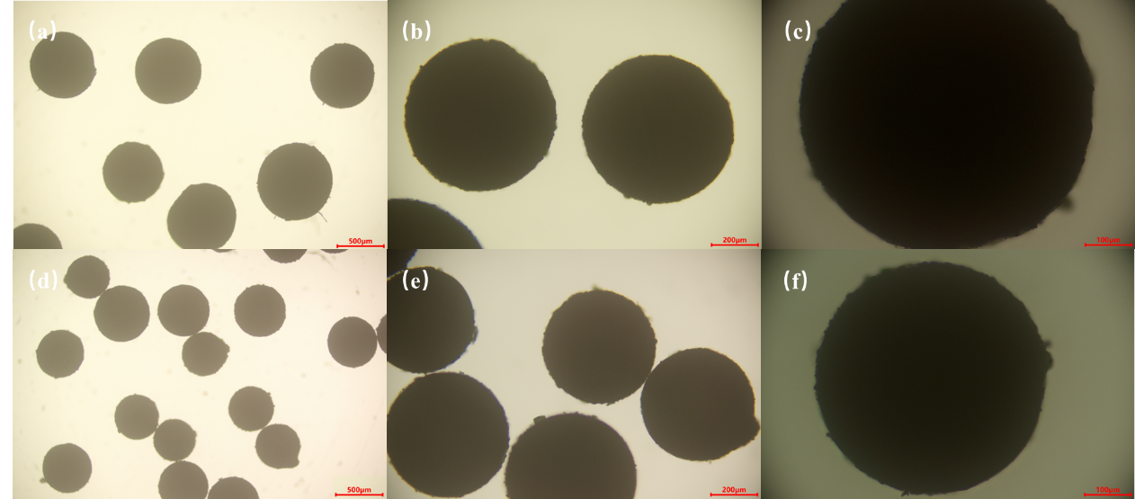
Figure 3-3 Optical micrographs of epoxy resin microspheres and Fe₃O₄@epoxy resin proppants
The upper row corresponds to epoxy resin microspheres, and the lower row to Fe₃O₄@epoxy resin proppants. (a) and (d): 40×; (b) and (e): 100×; (c) and (f): 200×.

3.3 Thermal Stability
As depicted in Figure 3-4, thermal analysis of the proppant reveals three distinct stages of thermal decomposition. The first stage (50–350 ℃) corresponds to a minor weight loss of 5.7037%, primarily attributed to the removal of adsorbed surface water and residual unevaporated ethanol within the microspheres (employed as a diluent for epoxy resin and modified nano‑Fe₃O₄@SA during synthesis). The second stage (350–400 ℃) constitutes the primary thermal decomposition region, arising from the cleavage of C–O–C and C–C bonds within the epoxy molecular chains and the degradation of the cross‑linked network, accompanied by the release of CO₂ and small‑molecule hydrocarbons. The DTG curve indicates that the temperature corresponding to the maximum weight loss rate of ESP-T is 357.27 ℃, with a mass loss of 72.4998%. In the third stage (>400 ℃), the sample mass remains relatively stable, with the residual weight loss originating from the oxidative combustion of carbide residues (coke) formed in the second stage under air atmosphere (producing CO₂). The residual components include hollow glass microspheres, thermally stable nano‑Fe₃O₄@SA nanoparticles, and a small amount of carbonaceous residues from epoxy decomposition.
The DSC curve characterizes the endothermic and exothermic behavior of the sample. As bond cleavage during epoxy decomposition is an endothermic process, a distinct endothermic peak appears in the corresponding temperature range. Substantial endothermic decomposition of the epoxy resin initiates at 332.41 ℃, peaks at 357.27 ℃ (corresponding to the maximum decomposition rate and maximum heat absorption), and completes at 371.58 ℃. The total endothermic enthalpy of epoxy decomposition is calculated as 99.53 mJ via integration.
The initial decomposition temperature of ESP-T is 357.27 ℃, which is far higher than the typical downhole temperature of oil–gas wells (80–150 ℃, up to 200 ℃ for deep wells). Only trace moisture volatilization occurs below 200 ℃ without any degradation of the epoxy matrix, fully satisfying the thermal stability requirements for long‑term downhole service. This further validates the reliability of ESP-T as a high‑performance fracturing proppant.
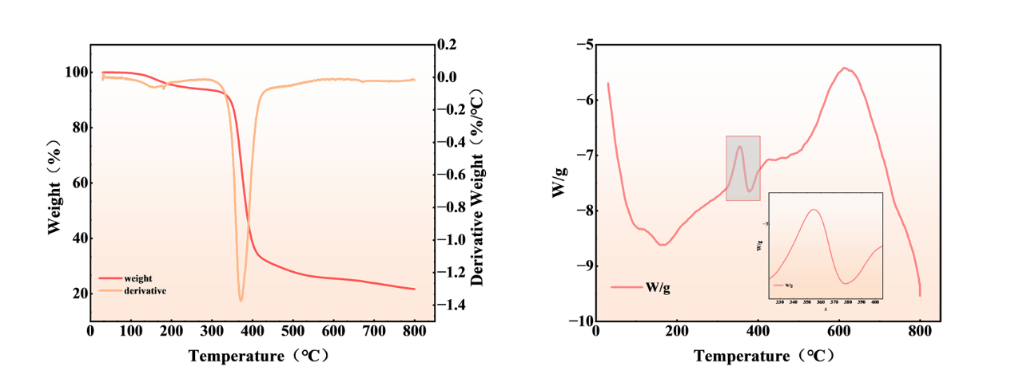
Figure 3 - 4 TGA/DTG and DSC curves of Fe3O4@epoxy resin proppant

3.4 Water Contact Angle (WCA)
Surface wettability of the two proppants was characterized using a video optical contact angle analyzer (OCA20, Germany). Three replicate measurements were conducted for each sample, and the average values were adopted for analysis (Figure 3–5). The average water contact angle (WCA) of neat epoxy resin microspheres is 72.3°, indicative of a weakly hydrophilic surface. This behavior arises from the hydroxyl groups (-OH) on the epoxy molecular chains, which form hydrogen bonds with water molecules and drive partial spreading of water droplets on the surface.
In contrast, the average WCA of ESP-T reaches 104.6°, corresponding to a distinct hydrophobic surface—an increment of 32.3° relative to neat epoxy microspheres, representing a significant wettability transition. This transformation is attributed to the stearic acid modification of nano‑Fe₃O₄@SA: the carboxyl groups (-COOH) of stearic acid (C₁₇H₃₅COOH) undergo a coordination reaction with surface hydroxyl groups of nano‑Fe₃O₄@SA to form stable chemical bonds, while the long alkyl chains (-C₁₇H₃₅) orient outward from the epoxy matrix, constructing a hydrophobic film on the proppant surface.
The surface enrichment of nano‑Fe₃O₄@SA nanoclusters observed via SEM further enhances this hydrophobic effect. The synergistic action of massive hydrophobic alkyl chains drastically reduces the surface free energy, suppresses water molecule spreading, and ultimately renders the proppant hydrophobic.
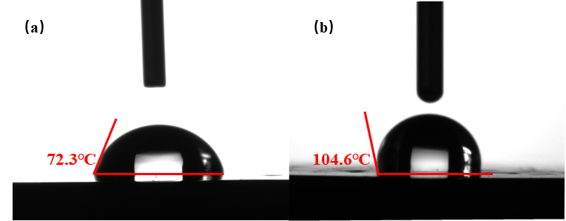
Figure 3 - 5 (a) WCA of epoxy resin patch (b) WCA of patch after doping with Nano - Fe₃O₄@SA

3.5 Sphericity and Roundness
Roundness and sphericity were determined by comparison with the Krumbien–Sloss chart [29]. Both values exceed 0.9, satisfying the industrial specifications (roundness ≥ 0.6, sphericity ≥ 0.6) and guaranteeing favorable fracture conductivity and pumpability of the proppants. This outcome demonstrates the exceptional controllability of the synthetic process over the spherical morphology of the microspheres.
A stirring rate of 380 RPM imparts uniform shear force to epoxy resin droplets within the nano-SiO₂ aqueous dispersion, favoring the formation of regularly spherical droplets. The subsequently introduced guar gum (0.9 g for neat epoxy resin microspheres and 1.1 g for ESP-T) elevates the system viscosity via thickening, thereby suppressing droplet deformation and sedimentation prior to curing. Hollow glass microspheres act as internal reinforcing supports, further preserving the structural integrity and ideal sphericity of the microspheres.

3.6 Bulk Density and Apparent Density
Figure 3-6 presents the bulk density and apparent density results of the two proppants. The average bulk density and apparent density of neat epoxy resin microspheres are 0.6179 g/cm³ and 1.02 g/cm³, respectively, while those of ESP-T are 0.646 g/cm³ and 1.072 g/cm³, respectively. Both density values of ESP-T are higher than those of neat epoxy microspheres, which is attributed to the much higher density of nano‑Fe₃O₄@SA (approximately 5.18 g/cm³) relative to epoxy resin (roughly 1.1 g/cm³). Even when dispersed as nanoclusters, nano‑Fe₃O₄@SA still leads to a notable increase in the overall density of the proppant.
Notably, the bulk density of both proppants is lower than that of water (1 g/cm³), implying that both can achieve favorable suspension in water‑based fracturing fluids and prevent wellbore blockage resulting from particle sedimentation. Despite the slight increase in bulk density, ESP-T remains within the readily suspendable range without the need for additional suspending agents. The 0.05 g/cm³ increment in the apparent density of ESP-T is associated with the filling of internal pores within the epoxy matrix by nano‑Fe₃O₄@SA nanoclusters. The incorporation of nano‑Fe₃O₄@SA reduces the internal closed pores of proppant particles, yielding a denser particle structure and providing a solid structural foundation for the subsequent low crush rate.
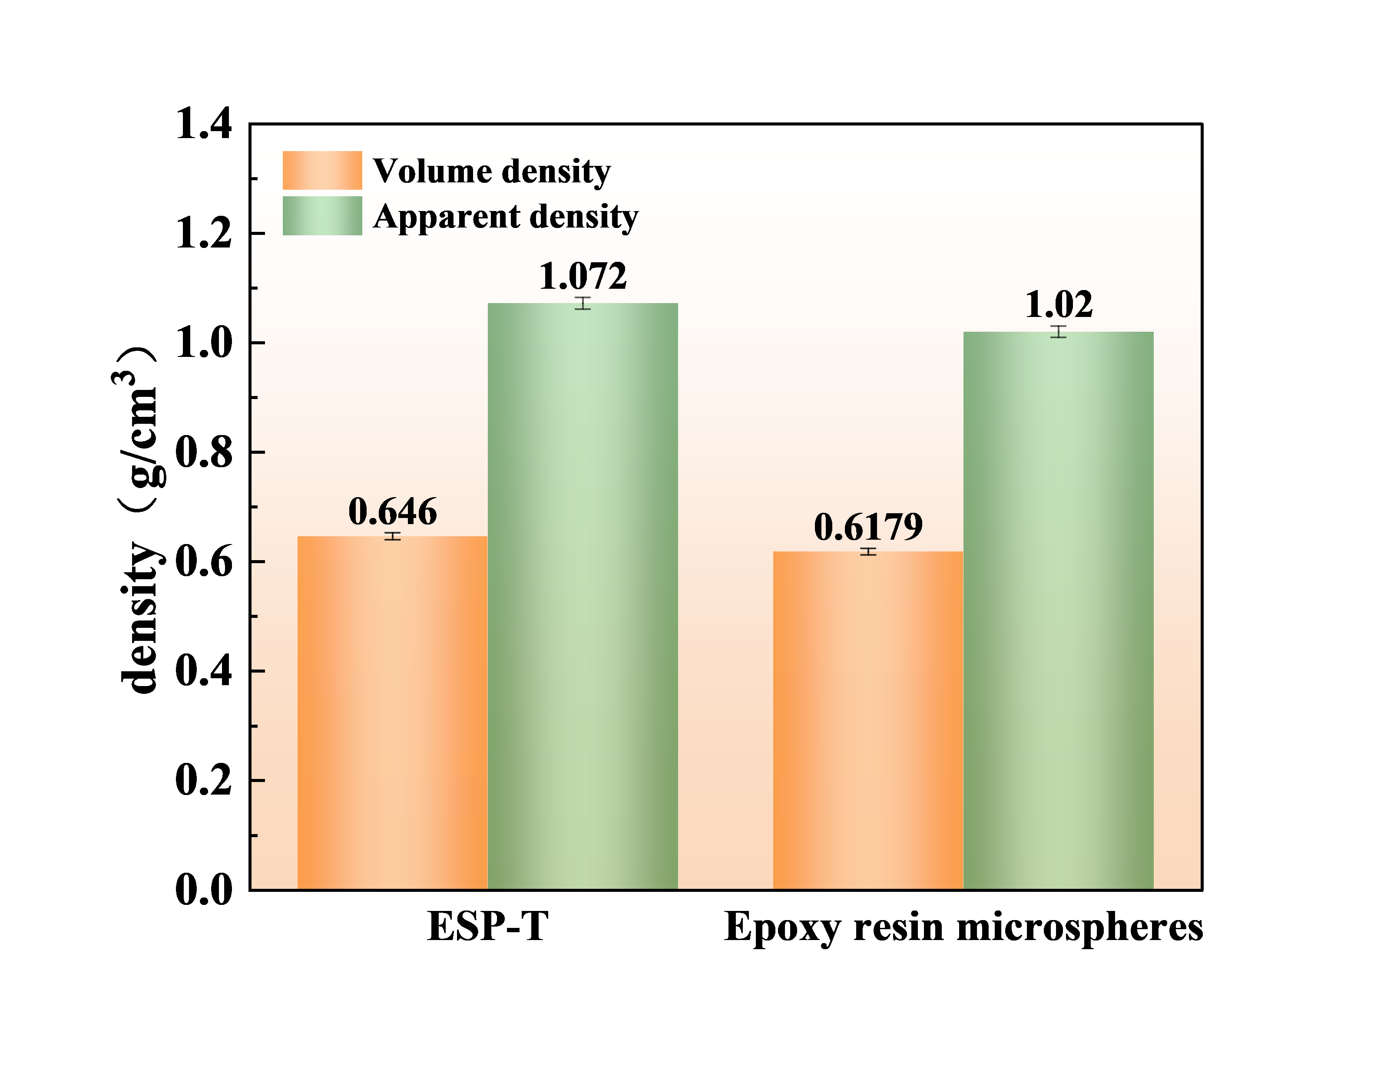
Figure 3 - 6 Bulk density and apparent density of epoxy microspheres and ESP – T

3.7 Acid Solubility
Acid solubility tests show ESP-T has a value of 3.3%, while neat epoxy resin proppants have 2.5%, with a negligible difference. Though nano‑Fe₃O₄@SA is soluble in dilute HCl and HF, the stearic acid-derived hydrophobic film shields its surface from acid attack, mitigating dissolution. Meanwhile, uniformly dispersed nano‑Fe₃O₄@SA nanoclusters act as an inorganic barrier in the epoxy matrix, slowing acid penetration and reducing resin degradation. Lower acid solubility indicates superior stability in acidic environments, ensuring long-term fracture propping integrity. Both proppants meet the industrial standard (acid solubility ≤5%), making them suitable for acid fracturing operations. Additionally, their acid solubility standard deviation is <0.2%, demonstrating stable dissolution behavior and excellent preparation reproducibility.

3.8 Breakage Rate
The crush rate of neat epoxy resin microspheres is 2.6% at 50 MPa, while that of ESP-T is 2.9% under the same pressure, with a negligible difference between the two proppants. This indicates that the incorporation of nano‑Fe₃O₄@SA exerts a minimal influence on the crush resistance of the proppants. The slight increase in the crush rate of ESP-T may be attributed to lattice defects introduced by metal doping into Fe₃O₄ and the marginally weakened interfacial adhesion between the nanofiller and epoxy matrix, which intensifies stress concentration under high pressure and marginally reduces the compressive strength. However, the uniformly dispersed nano‑Fe₃O₄@SA nanoclusters in the modified epoxy matrix optimize load transfer and inhibit crack initiation and propagation, ultimately resulting in comparable crush performance between ESP-T and neat epoxy resin microspheres.

3.9 Proppant Conductivity (Filtration Time)
The conductivity of proppants can be indirectly evaluated by the "oil-water filtration time": a shorter filtration time indicates lower flow resistance of fluid (water or oil) through the proppant pack and better conductivity. The water and oil filtration times of the two proppants were experimentally measured, as illustrated in Figure 3-7 and tabulated in the results. The water filtration time of neat epoxy resin microspheres was 2 min 53 s, whereas that of ESP-T was 28 min 41 s. The hydrophobicity of Nano-Fe₃O₄@SA@epoxy proppant hinders the spreading and flow of the aqueous phase within the proppant pores; water molecules must overcome the repulsive force of the hydrophobic surface to penetrate these pores, thereby increasing flow resistance and prolonging filtration time. In contrast, the oil filtration time of neat epoxy resin microspheres was 15 min 11 s, and that of ESP-T was 5 min 11 s. The hydrophobic surface of Nano-Fe₃O₄@SA@epoxy proppant exhibits good compatibility with the oil phase, enabling rapid spreading within the proppant pores and significantly reducing flow resistance, thus shortening the filtration time. Consequently, ESP-T exhibits the characteristic feature of "increased water resistance and reduced oil resistance". In formations containing both oil and water phases, the proppant pack exhibits enhanced conductivity to the oil phase, promoting the rapid flow of oil toward the wellbore. Meanwhile, the increased flow resistance to the aqueous phase mitigates water channeling to a certain extent, thereby improving crude oil recovery and demonstrating its great potential for enhancing oil recovery in hydraulic fracturing applications.
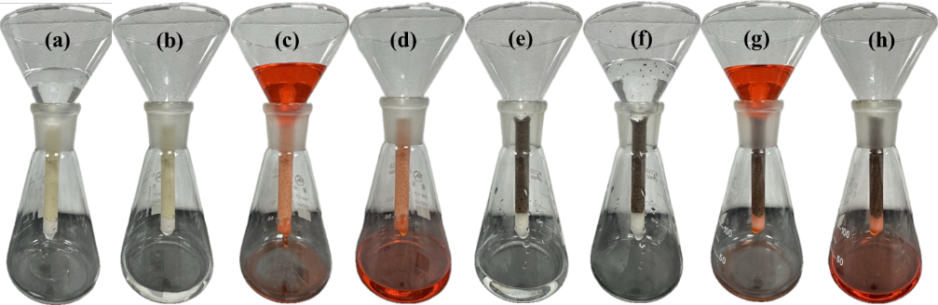
Figure 3-7 Oil-water permeability test of epoxy resin microspheres and ESP-T
(a)(b) before and after water passing through epoxy resin microspheres, (c)(d) before and after oil passing through epoxy resin microspheres, (e)(f) before and after water passing through ESP-T, (g)(h) before and after oil passing through ESP-T.

Table 3-1 Oil and Water Passage Time
 | ESP-T | Epoxy resin microspheres
Water passage time | 28：41 | 2：53
oil passage time | 5：14 | 15：11

3.10 Release Behavior of ESP-T at Different Temperatures
In field applications, formation temperature rises with increasing reservoir depth, impacting the expansion of ESP-T and tracer release behavior. The release profiles of ESP-T at various temperatures are presented in Figure 3-8(a), where C/C₀ represents the normalized concentration,C denotes the tracer concentration at a specific time, and C₀ is the maximum release concentration. As indicated by these profiles, the relative release concentration increases over time and with rising temperature, demonstrating that elevated temperature accelerates tracer release. Additionally, Figure 3-8(c) shows that the tracer release rate is high during the initial contact with the fluid, then gradually slows and stabilizes over time. The cumulative tracer release at 120 °C over 14 days remains detectable by ICP-MS, confirming its suitability for long-term, effective, and stable monitoring. To better understand the release behavior and mechanism of tracers within the carrier and optimize tracer design, the release mechanism and kinetic characteristics of ESP-T were investigated. In this study, the Korsmeyer-Peppas (K-P) release kinetic model was used to fit the release curves at different temperatures, and the release behavior of ESP-T was interpreted based on the fitted parameters. The K-P model is defined by Equation (5):
$$\begin{aligned}\frac{C}{C_{0}}=Kt^{n}\#\left(5\right)\end{aligned}$$
Where:
C = tracer concentration at a certain time (mg/L);
C₀ = maximum release concentration (mg/L);
K = kinetic constant;
t = release time (h);
n = diffusion exponent.

The Korsmeyer-Peppas (K-P) model is a power-law mathematical model developed by Korsmeyer and Peppas, widely employed to characterize the release behavior of controlled-release systems. It describes two key mechanisms: Fickian diffusion—where substances diffuse from high- to low-concentration regions in accordance with Fick’s laws—and Case-II relaxation—where polymers swell and increase internal porosity upon contact with specific fluids, facilitating the release of entrapped substances. For spherical carriers, the release mechanism is determined by the diffusion exponent n:n ≤0.45 (dominated by Fickian diffusion);0.45 < n < 0.85 (co-controlled by both mechanisms); and n ≥0.85 (dominated by Case-II relaxation).K-P model fitting results for the experimental data are presented in Figure 3-8(b), with detailed fitting parameters summarized in Table 3-2. As illustrated by the fitting curves, the release rate gradually stabilizes over time. The kinetic constant K increases with temperature, indicating that the release rate accelerates with rising temperature. Notably, all n values fall within the range of 0.45–0.85, confirming that ESP-T’s release follows an anomalous diffusion mechanism involving the combination of Fickian diffusion and Case-II relaxation. Furthermore, the coefficient of determination (R²) exceeds 0.90 for all test temperatures, demonstrating that the K-P model accurately describes ESP-T’s release behavior across different temperatures and provides reliable technical support for its practical application.
Based on the release results, the release mechanism of ESP-T is inferred as follows: During the release process, nonpolar solvents (e.g., alkanes) permeate into the polymer network, inducing swelling of the cross-linked epoxy matrix (note: corrected from "polystyrene-divinylbenzene" to align with ESP-T’s epoxy-based composition). At this stage, the polymer microspheres form a dual-state structure: an inner glassy core and an outer gel layer. This swelling process reduces the entanglement of polymer molecular chains, thereby forming expanded transport channels that enable tracers to diffuse into the external environment. Elevated temperature enhances the permeability of solvent molecules into the polymer matrix, accelerating the swelling rate. Furthermore, increased temperature weakens the intermolecular forces within the polymer network, expanding the pore size and further promoting tracer diffusion through the matrix.
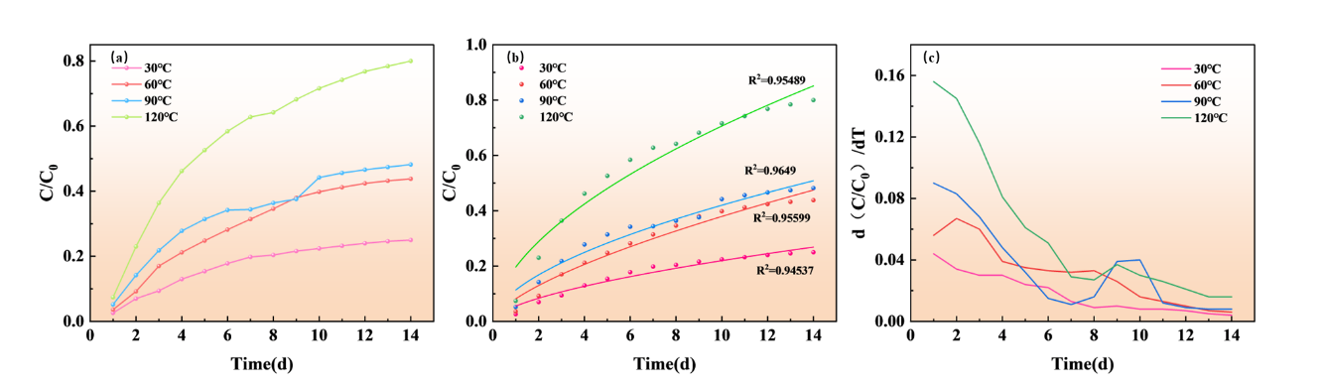
Figure 3-8 (a) Release curves of ESP-T at different temperatures (b) K-P model fitting curves (c) Release rate change curves of ESP-T
Table 3-2 Fitting Parameters of K-P Model
K-P model |  | C/C₀ =Kt^n
Fit parameters |  | release temperature
 | 30℃ |  | 60℃ | 90℃ | 120℃
R² | 0.95489 |  | 0.9649 | 0.95599 | 0.94537
K | 0.05538 |  | 0.08177 | 0.11344 | 0.19642
n | 0.59827 |  | 0.66646 | 0.5684 | 0.55569

3.11 Oil Production Monitoring of ESP-T
To highlight the characteristics of the tracer production curve, a well shut-in phase was incorporated into the experimental design to achieve enhanced tracer release. Continuous sampling was employed, with a sample volume of 2 mL, a wellhead flow rate of 0.5 mL/min, and a sampling interval of 4 min. Owing to the effect of sample volume, the actual arrival time of the tracer concentration peak at the wellhead falls within the range of 20–25 min. Figure 3-9(a) presents the tracer production profile. To facilitate effective analysis of the tracer system’s response time, the concentration data were normalized. As clearly illustrated in the figure, the tracer concentration exhibits the characteristic of “initial rapid rise followed by stabilization,” with a distinct concentration peak corresponding to the high-concentration tracer solution generated by ESP-T during the shut-in period. The initial rapid rise arises from the accelerated release of residual tracers (unreleased during the static period) under fluid shear, while the subsequent stabilization indicates that the concentration enters a steady state. This observation is consistent with the findings in Section 3.10: ESP-T realizes synergistic tracer release via Fickian diffusion and Case-II relaxation, enabling sustained stable tracer signals under constant flow conditions.

To further clarify tracer release behavior in single-phase flow and optimize tracer application, the tracer release profile was fitted using a dynamic tracer release interpretation model, as defined in Equation (6):
$$\begin{aligned}\left\{\begin{aligned}&C_{1}=\frac{Ad}{\sqrt{16αQt}}\exp\left[-\frac{{\left(xπd^{2}-4Qt\right)}^{2}}{16αQtπd^{2}}\right] t<t_{0} \\ &C_{2}=\frac{a}{2}erfc\left(\frac{xπd^{2}-4Qt}{\sqrt{16αQtπd^{2}}}\right) t≥t_{0}\end{aligned}\right.\#\left(6\right)\end{aligned}$$
Where:
A = accumulation of tracers on the one-dimensional axis when t < t₀;
x = fluid flow distance;
v = Darcy velocity of fluid;
t = time;
α = diffusion constant;
Q = flow rate;
d = wellbore diameter.
The dynamic release model is established based on the one-dimensional convective-diffusion equation and the migration behavior of tracer slugs, which decomposes the slow-release tracer production curve into a single-peak accumulation stage and a steady-state tailing stage. The single-peak stage is characterized using a slug model, while the steady-state stage is solved by re-deriving the governing equation with the zero-order kinetic release rate as the boundary condition. By introducing and simplifying parameters including the diffusion constant(α), flow rate(Q), partition coefficient(φᵢ), partition flow rate(qᵢ), and wellbore diameter(d), a dynamic release interpretation model for slow-release tracer plumes is developed.

The fitting results are presented in Figure 3-9(b), with coefficients of determination (R²) exceeding 0.9. A comparison between the actual pump-set flow rate and the fitted flow rate is shown in Figure 3-9(c). The experimental pump-set flow rate is 0.5 mL/min, and the fitted flow rate is 0.46 mL/min. The difference between the fitted and set values of the constant-flow pump is small, yielding a relative error of 8%. The actual oil production falls within the error range of the calculated values, demonstrating the feasibility of ESP-T for monitoring oil production from fractured intervals in oilfield applications.
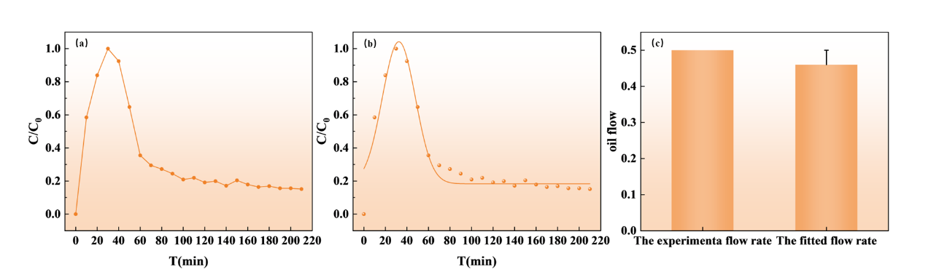
Figure 3-9 (a) Tracer release production curve of ESP-T single-phase flow monitoring (b) Fitting curve of ESP-T tracer release model (c) Comparison of pump set flow rate and fitted flow rate

To explore the influence of oil–water two-phase flow on ESP-T-based oil production monitoring, the system was maintained in a steady-state flow regime to ensure stable tracer release. Direct observation of the effluent after two-phase displacement at an oil–water ratio (OWR) of 1:1 revealed a slightly higher oil phase fraction in the early-stage effluent, consistent with the findings in Section 3.9. This confirms that ESP-T exhibits favorable oil-phase conductivity, rendering the oil phase the dominant flow pathway during production.
Figure 3-10(a) illustrates the relationship between tracer concentration, total two-phase flow rate, and OWR. As shown, tracer concentration gradually decreases with increasing total two-phase flow rate, with negligible dependence on OWR. This phenomenon arises because elevated total flow rate shortens the residence time of the unit-volume liquid phase in contact with ESP-T, reducing the total tracer released per unit volume of liquid and thus lowering the effluent tracer concentration.
During steady-state production, tracer concentration remains low, and the production curve typically only reflects concentration data—interpretation of this regime relies on concentration magnitude and trends. To quantify the single-interval oil flow rate, tracer flux (FO) was introduced. FO is defined as the mass of tracer passing through the wellhead sampling point per unit time, which equals the tracer release rate of ESP-T. Figure 3-10(b) shows the variation in FO: it increases with OWR but is independent of total two-phase flow rate. At a constant OWR, the contact area between ESP-T and the oil phase remains unchanged, so FO stays constant regardless of total flow rate. Conversely, increasing OWR expands the oil-phase contact area with ESP-T, leading to higher FO.
Figure 3-10(c) compares the normalized FO with the actual oil-phase flow rate at different OWRs (total two-phase flow rate = 0.1 mL/min). The normalized FO was calibrated against the steady-state FO during single-phase oil displacement (3.187 μg/min). The results demonstrate an excellent fitting degree between FO and the actual oil-phase flow rate across various OWRs. Thus, under steady-state two-phase flow conditions, the oil-phase flow rate in the labeled interval can be quantified from the FO variation curve when the total two-phase flow rate is constant.
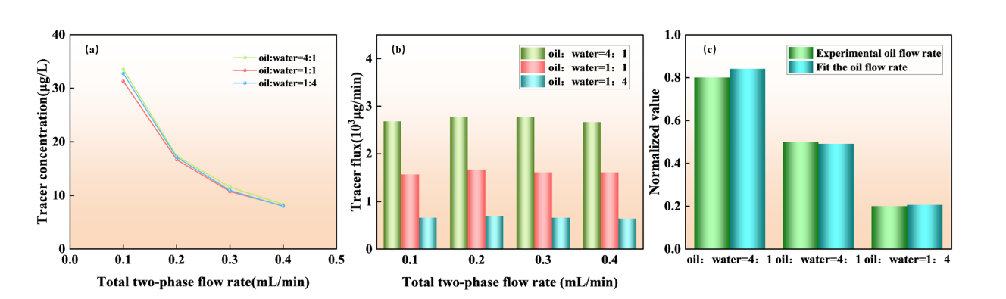
Figure 3-10 (a) Tracer concentration changes with oil-water ratio and total two-phase flow (b) Tracer flux changes with oil-water ratio and total two-phase flow (c) Comparison of tracer flux and actual flow under different oil-water ratios at a flow rate of 0.1 mL/min

4. Conclusions
Oleophilic nano-Fe₃O₄@SA nanoparticles were synthesized via coprecipitation and modified with stearic acid, and ESP-T was subsequently fabricated via emulsion polymerization. Scanning electron microscopy (SEM), elemental mapping, and optical microscopy revealed that nano-Fe₃O₄@SA was uniformly dispersed in the epoxy matrix as nanoclusters without significant agglomeration. The proppant exhibited excellent sphericity and roundness (>0.9), satisfying industrial molding standards.

ESP-T demonstrated superior physical, mechanical, and thermal stability: a bulk density of 0.646 g/cm³ ensured good suspension in water-based fracturing fluids; an apparent density of 1.072 g/cm³ indicated a compact structure; a high compressive strength at 50 MPa; an acid solubility of 3.3% (≤5%, meeting industry requirements for acidic reservoirs); and an initial thermal decomposition temperature of 357.27 ℃, far exceeding the downhole temperature range (80–200 ℃), ensuring long-term thermal stability without resin degradation. Its surface water contact angle increased from 72.3° (weakly hydrophilic for neat epoxy) to 104.6° (hydrophobic), exhibiting the characteristic "water-resistant and oil-permeable" conductivity. The water filtration time reached 28 min 41 s (significantly longer than neat epoxy), while the oil filtration time was 5 min 11 s (66.1% shorter), facilitating oil flow and inhibiting water breakthrough.

In terms of tracer performance, Fe release at 30–120 ℃ followed the Korsmeyer–Peppas (K-P) model. Fitting results showed that the diffusion exponent(n) ranged from 0.45 to 0.85 at all temperatures, indicating a synergistic release mechanism governed by both Fickian diffusion and Case-II relaxation, with a coefficient of determination (R²) > 0.90. The cumulative tracer release at 120 ℃ over 14 days exceeded 2.0 mg/L, meeting ICP-MS detection sensitivity for long-term monitoring. During shut-in single-phase flow, the dynamic release interpretation model achieved (R² > 0.9), with a fitted flow rate of 0.46 mL/min (relative error = 8% vs. set flow rate of 0.5 mL/min), validating accurate single-phase oil production monitoring. Under steady-state two-phase flow, tracer concentration decreased with increasing total flow rate but remained unaffected by oil–water ratio. Tracer flux effectively quantified oil-phase flow rates in individual intervals, supporting dynamic production monitoring during steady-state conditions.

In summary, ESP-T integrates fracture propping and tracer monitoring, making it suitable for acid fracturing operations, deep wells, and high-pressure formations. It provides reliable technical support for fracturing optimization and enhanced oil recovery, demonstrating significant industrial application potential.

References
[1] CHONG Z R, YANG S H B, BABU P, et al. Review of natural gas hydrates as an energy resource: Prospects and challenges [J]. Applied Energy, 2016, 162: 1633-52.
[2] MONTGOMERY S L, JARVIE D M, BOWKER K A, et al. Mississippian Barnett Shale, Fort Worth basin, north-central Texas: Gas-shale play with multi–trillion cubic foot potential [J]. AAPG Bull, 2005, 89(2): 155-75.
[3] ROGNER H-H. AN ASSESSMENT OF WORLD HYDROCARBON RESOURCES [J]. Annu Rev Energy Env, 1997, 22(1): 217-62.
[4] MOHR S H, WANG J, ELLEM G, et al. Projection of world fossil fuels by country [J]. Fuel, 2015, 141: 120-35.
[5] WANG L, TIAN Y, YU X, et al. Advances in improved/enhanced oil recovery technologies for tight and shale reservoirs [J]. Fuel, 2017, 210: 425-45.
[6] IEA. https://www.iea.org/reports/world-energy-employment-2025 [Z]. 2025
[7] HE X, ZHANG P, GAO Y, et al. Challenges and countermeasures for beneficial development of unconventional oil and gas resources in China [J]. China Petroleum Exploration, 2025, 30(1): 28-43.
[8] BARATI R, LIANG J T. A review of fracturing fluid systems used for hydraulic fracturing of oil and gas wells [J]. J Appl Polym Sci, 2014, 131(16).
[9] MEDEIROS F, KURTOGLU B, OZKAN E, et al. Analysis of Production Data From Hydraulically Fractured Horizontal Wells in Shale Reservoirs [J]. Spe Reservoir Evaluation & Engineering, 2010, 13(3): 559-68.
[10] PATIDAR A K, JOSHI D, DRISTANT U, et al. A review of tracer testing techniques in porous media specially attributed to the oil and gas industry [J]. Journal of Petroleum Exploration and Production Technology, 2022, 12(12): 3339-56.
[11] SANNI M, AL-ABBAD M, KOKAL S, et al. Pushing the envelope of residual oil measurement: A field case study of a new class of inter-well chemical tracers [J]. Journal of Petroleum Science and Engineering, 2018, 163: 538-45.
[12] SILVA M, STRAY H, BJøRNSTAD T. Stability assessment of PITT tracer candidate compounds – The case of pyrazines [J]. Journal of Petroleum Science and Engineering, 2019, 182.
[13] WATKINS J W, MARDOCK E S. Use of radioactive iodine as a tracer in water-flooding operations [J]. J Pet Technol, 1954, 6(09): 117-24.
[14] YANG H, GUO K, LIN L, et al. Application of micro-substance tracer test in fractured horizontal wells [J]. Journal of Petroleum Exploration and Production Technology, 2024, 14(5): 1235-46.
[15] ZHAO B, PANTHI K, MOHANTY K K. Tracer eluting proppants for hydraulic fracture characterization [J]. Journal of Petroleum Science and Engineering, 2020, 190.
[16] ZHOU Y, LIU H, GAO J, et al. Coated proppants with self-suspension and tracer slow-release functions [J]. Journal of Petroleum Science and Engineering, 2022, 208.
[17] MALYAVKO E, UPADHYE V, HUSEIN N. Research of Operational Dynamics of a Well with Two Hydraulic Fractures with Use of Marked Proppant Penetrating into One Productive Formation [Z]. SPE International Hydraulic Fracturing Technology Conference and Exhibition. 2023.10.2118/215624-ms
[18] LI N, CHENG Q, GONG Z, et al. Release kinetics of rare earth tracer from polymer-coated proppants for hydraulic fracture analysis [J]. Geoenergy Science and Engineering, 2023, 227.
[19] GONG Z, LI N, KANG W, et al. Novel oleophilic tracer-slow-released proppant for monitoring the oil production contribution [J]. Fuel, 2024, 364.
[20] WANG G, MA Q, REN L, et al. A Comprehensive Review of Multifunctional Proppants [J]. ACS Omega, 2024, 9(44): 44120-33.
[21] KRISHNAN M R, LI W, ALHARBI B, et al. In-Situ High-Strength Poly(styrene-methyl methacrylate)-2D Nanofiller Composite Microbeads as Potential Proppants in Hydraulic Fracturing [J]. Geoenergy Science and Engineering, 2025, 257: 214195.
[22] GUO X, WEI K, NI T, et al. Preparation and performance analysis of polyethylene glycol/epoxy resin composite phase change material [J]. Journal of Energy Storage, 2024, 88.
[23] LIANG C, LUO W, YAN C, et al. Ultra-lightweight Proppant Synthesized from PMMA/Pine Bark Composite: Low-cost Material and Outstanding Properties [J]. Chem Lett, 2016, 45(8): 994-6.
[24] ZOVEIDAVIANPOOR M, GHARIBI A, BIN JAAFAR M Z. Experimental characterization of a new high-strength ultra-lightweight composite proppant derived from renewable resources [J]. Journal of Petroleum Science and Engineering, 2018, 170: 1038-47.
[25] SABINS F, APBLETT A, SHAFER R, et al. Epoxy Resin Exhibits Long-Term Durability and Chemical Stability as a Well Sealant [J]. SPE International Conference on Oilfield Chemistry, 2021.
[26] LI H, LIU Z, LI Y, et al. Evaluation of the Release Mechanism of Sustained-Release Tracers and its Application in Horizontal Well Inflow Profile Monitoring [J]. ACS Omega, 2021, 6(29): 19269-80.
[27] WEI M, WANG Y, DUAN Y, et al. Screening and performance evaluation of epoxy resin long-term sustained-release solid tracer [J]. Int J Oil Gas Coal Technol, 2024, 36(2): 170-96.
[28] GONG Z, LI N, QIN M, et al. Magnetic nano-Fe3O4-based oleophilic tracer for stability studies of nano-tracer in oilfields condition [J]. Colloids and Surfaces A: Physicochemical and Engineering Aspects, 2024, 683.
[29] KRUMBEIN W C, SLOSS L L. Stratigraphy and sedimentation [M]. LWW, 1951.

